Courage Heart Dwellers, Courage
October 21st, 2021

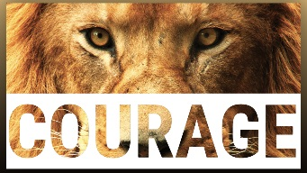
Lord, please sustain us through every crisis, so that we do not waver when the world is in turmoil and confusion. Please give us the courage to be Your vessels of hope. Amen.

The message began, “Many things are coming to a head. The worst is yet to come. All of you must keep an eye on your faith, that it stays strong with all the events that are coming. Some of them will be terrifying, but you have been fore warned so nothing will be a surprise to you. Your children will wake up Clare, but it will take a lot to jar them loose from their matrix. Don’t worry about them, the Lord has them covered. There will be much shame for the way they ignored you. You tried, that is all that He asked of you.

“Each day evil increases in the world. Plans are moving forward to take over the world. China has worked very hard, long and hard, to bring this about. The Lord anticipated delays you would face and He has made provision. You are right on target with your preparations.”

“Thank you for telling me that, it relieves some pressure.”

“Please do not lose sight of the prayer burden We have entrusted to this community and all Heart Dwellers. Each day you pray, thousands are being prepared, truly your simple intentions are having an impact on the lives of so many who would not have made it otherwise. As you apply your hearts to praying for them, we are preparing things for you as well. You cannot out give the Lord.

“Prayer vigils are very effective and cover for many calamities that might happen during those hours. Thank you for that.”

“Mother can you speak on the remnant church.”

“You are the remnant church and all that you have been going through is just a foretaste of what is to come. It is wisdom to keep things more anonymous, but that point was passed a long time ago. As you move forward, those are good measures to take. There are many around the world that have gone underground.”

As we were praying the Sorrowful mysteries of the Rosary, three people in the room saw her animate, in the Mother of Mercy painting. She was holding the world in her hands, and two other people saw her draw her mantle over the world as it became dark, then, when she removed it, light had returned and the earth was rejuvenated. On another day, a sister saw the earth turn from normal to black ash, then back to normal, once more. We sensed that this was about the purification by fire the Scriptures talk about.

God bless you dear ones and thank you so much for your prayers and support. We love you and pray for all of us to be equipped and enable to do His Will.

